Week 1
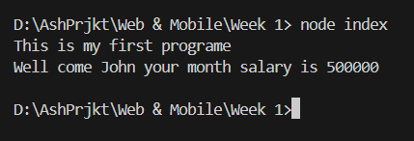
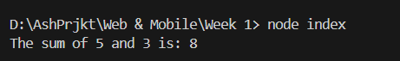
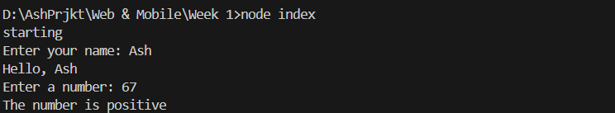
In Week 1, I learned how to set up Visual Studio Code and Node.js to write my first JavaScript program. I created a file called index.js and used console.log() to print messages. I also wrote simple programs to add numbers and check if a number is positive or negative. At first, I had some trouble running my code because I was in the wrong folder, but I learned to use commands like cd and pwd to fix it. This lab helped me understand how to write and run JavaScript code.

